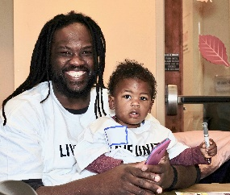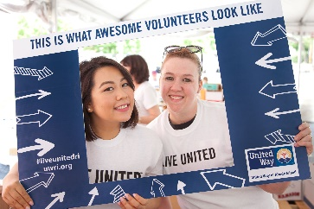
2019-2020 Campaign Social Media Kit
Just copy and paste to share on all of your social media channels. It’s that simple! Because everyone needs help sometimes, @LiveUnitedRI helps. We can’t do it alone. Join us.

DYK? $1 a week could help two families get their taxes done for free through Volunteer Income Tax Assistance. uwriweb.org/onlinegive

DYK? $3 a week could help a struggling family with emergency rental assistance. uwriweb.org/onlinegive

DYK? $5 a week could send the @LiveUnitedRI 211 RV to a community event. uwriweb.org/onlinegive

DYK? $12 a week could help pay the heat and electricity for an elderly neighbor. uwriweb.org/onlinegive

DYK? $20 a week could send one child to an amazing summer learning program. uwriweb.org/onlinegive

DYK? $50 a week could support adult education & job training to put one Rhode Islander on a path to a better career. uwriweb.org/onlinegive

@LiveUnitedRI invests in proven programs that bring real results. #JoinUs #Give uwriweb.org/onlinegive

@LiveUnitedRI provides one place for everyone to call when they need help — 211. #JoinUs #Give uwriweb.org/onlinegive

Rhode Islanders just like you need our help, and @LiveUnitedRI has the data to prove it. #JoinUs #Give uwriweb.org/onlinegive

Every $1 donated to the @LiveUnitedRI Community Impact Fund can change lives. Help someone in RI today. #JoinUs #Give uwriweb.org/onlinegive

Making sure that our neighbors have what they need is possible — all we need is you. #JoinUs #LiveUnitedRI uwriweb.org/onlinegive

What changes do you want to see? Join @LiveUnitedRI, and let’s make Rhode Island better, together. #Give uwriweb.org/onlinegive

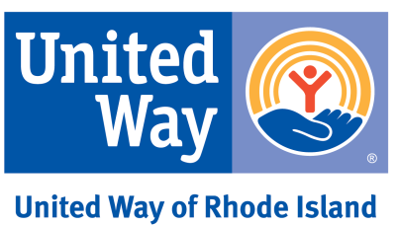
Give to the Community Impact Fund today. When Rhode Islanders help Rhode Islanders, we all can thrive. #LiveUnitedRI uwriweb.org/onlinegive

